Title in English. (Times New Roman, bold, 18 pts)
John DOE¹, King ARTHUR^{2*} (First name + Last name -capital-; bold, 12pt)
¹Great Laboratory (Times New Roman, 11pt), Privet Drive - Suite 007 (France)
²son of Uther Pendragon, from the castle of Camelot. King of the Britons, defeater of the Saxons, Sovereign of all England , 13, Diagon Alley - London (UK)
*(Corresponding author: degun@levelodrome.fr)

The whole document should not exceed 1 page ; The text must be in Times New Roman, 12pt.
A 0.5 cm tabulation is present. Two consecutive paragraphs are separated by a 0.3 cm space. The rest of the text must use a simple interline and is justified.
Margin of the document are: left=2cm, right=2cm, top=3.5cm, bottom=2.5cm
Your abstract must be exported in pdf and submitted on the jdd2026.
In order to depose your abstract you must use or create a scienceconfs ID (will be usefull along your PhD)
(OPTIONAL) Figures can be grouped altogether at the end of the text, after the bibliography, or be inserted in the text at the best place.

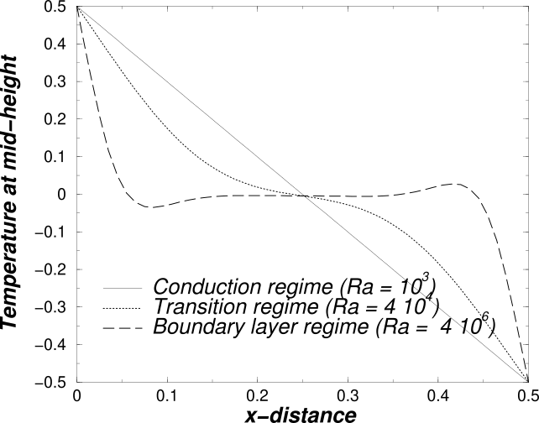
Figure 1: Title in italic (Times New Roman 11 pts)

References (by order of appearance in the text, 11 pt)
- G. W. Bush, What to do ?, Int. J. Fund. Quest., 35-10 (2003), 1789-1871.
- Mickey 2Gen, Universality in question, Presses Universitaires du Plateau (1999).
- J. "Salty" Marsh, Blablablah as a managing technique, Proc. Phys. Soc. Mont. Ste. Gen. (St Michel-en-Grève, 1-30 sept. 1987), 142-372.
Acknowledgements (Times New Roman , 12 pts)
(OPTIONAL) We would like to thank [...].

